**SOURCE CODE**

1. #include <stdio.h>
2. #include <math.h>
4. int a = 0,b = 0, c = 0, a1 = 0, b1 = 0, com[5] = { 1, 0, 0, 0, 0};
5. int anum[5] = {0}, anumcp[5] = {0}, bnum[5] = {0};
6. int acomp[5] = {0}, bcomp[5] = {0}, pro[5] = {0}, res[5] = {0};
8. void binary(){
9. a1 = fabs(a);
10. b1 = fabs(b);
11. int r, r2, i, temp;
12. for (i = 0; i < 5; i++){
13. r = a1 % 2;
14. a1 = a1 / 2;
15. r2 = b1 % 2;
16. b1 = b1 / 2;
17. anum[i] = r;
18. anumcp[i] = r;
19. bnum[i] = r2;
20. **if**(r2 == 0){
21. bcomp[i] = 1;
22. }
23. **if**(r == 0){
24. acomp[i] =1;
25. }
26. }
27. //part for two's complementing
28. c = 0;
29. for ( i = 0; i < 5; i++){
30. res[i] = com[i]+ bcomp[i] + c;
31. **if**(res[i] >= 2){
32. c = 1;
33. }
34. **else**
35. c = 0;
36. res[i] = res[i] % 2;
37. }
38. for (i = 4; i >= 0; i--){
39. bcomp[i] = res[i];
40. }
41. //**in** case **of** negative inputs
42. **if** (a < 0){
43. c = 0;
44. for (i = 4; i >= 0; i--){
45. res[i] = 0;
46. }
47. for ( i = 0; i < 5; i++){
48. res[i] = com[i] + acomp[i] + c;
49. **if** (res[i] >= 2){
50. c = 1;
51. }
52. **else**
53. c = 0;
54. res[i] = res[i]%2;
55. }
56. for (i = 4; i >= 0; i--){
57. anum[i] = res[i];
58. anumcp[i] = res[i];
59. }
61. }
62. **if**(b < 0){
63. for (i = 0; i < 5; i++){
64. temp = bnum[i];
65. bnum[i] = bcomp[i];
66. bcomp[i] = temp;
67. }
68. }
69. }
70. void add(int num[]){
71. int i;
72. c = 0;
73. for ( i = 0; i < 5; i++){
74. res[i] = pro[i] + num[i] + c;
75. **if** (res[i] >= 2){
76. c = 1;
77. }
78. **else**{
79. c = 0;
80. }
81. res[i] = res[i]%2;
82. }
83. for (i = 4; i >= 0; i--){
84. pro[i] = res[i];
85. printf("%d",pro[i]);
86. }
87. printf(":");
88. for (i = 4; i >= 0; i--){
89. printf("%d", anumcp[i]);
90. }
91. }
92. void arshift(){//for arithmetic shift right
93. int temp = pro[4], temp2 = pro[0], i;
94. for (i = 1; i < 5  ; i++){//shift **the** MSB **of** product
95. pro[i-1] = pro[i];
96. }
97. pro[4] = temp;
98. for (i = 1; i < 5  ; i++){//shift **the** LSB **of** product
99. anumcp[i-1] = anumcp[i];
100. }
101. anumcp[4] = temp2;
102. printf("\nAR-SHIFT: ");//display together
103. for (i = 4; i >= 0; i--){
104. printf("%d",pro[i]);
105. }
106. printf(":");
107. for(i = 4; i >= 0; i--){
108. printf("%d", anumcp[i]);
109. }
110. }
112. void main(){
113. int i, q = 0;
114. printf("\t\tBOOTH'S MULTIPLICATION ALGORITHM");
115. printf("\nEnter two numbers to multiply: ");
116. printf("\nBoth must be less than 16");
117. //simulating for two numbers **each** below 16
118. do{
119. printf("\nEnter A: ");
120. scanf("%d",&a);
121. printf("Enter B: ");
122. scanf("%d", &b);
123. }while(a >=16 || b >=16);
125. printf("\nExpected product = %d", a * b);
126. binary();
127. printf("\n\nBinary Equivalents are: ");
128. printf("\nA = ");
129. for (i = 4; i >= 0; i--){
130. printf("%d", anum[i]);
131. }
132. printf("\nB = ");
133. for (i = 4; i >= 0; i--){
134. printf("%d", bnum[i]);
135. }
136. printf("\nB'+ 1 = ");
137. for (i = 4; i >= 0; i--){
138. printf("%d", bcomp[i]);
139. }
140. printf("\n\n");
141. for (i = 0;i < 5; i++){
142. **if** (anum[i] == q){//just shift for 00 **or** 11
143. printf("\n-->");
144. arshift();
145. q = anum[i];
146. }
147. **else if**(anum[i] == 1 && q == 0){//subtract **and** shift for 10
148. printf("\n-->");
149. printf("\nSUB B: ");
150. add(bcomp);//add two's complement **to** implement subtraction
151. arshift();
152. q = anum[i];
153. }
154. **else**{//add ans shift for 01
155. printf("\n-->");
156. printf("\nADD B: ");
157. add(bnum);
158. arshift();
159. q = anum[i];
160. }
161. }
163. printf("\nProduct is = ");
164. for (i = 4; i >= 0; i--){
165. printf("%d", pro[i]);
166. }
167. for (i = 4; i >= 0; i--){
168. printf("%d", anumcp[i]);
169. }
170. }

**OUTPUT**

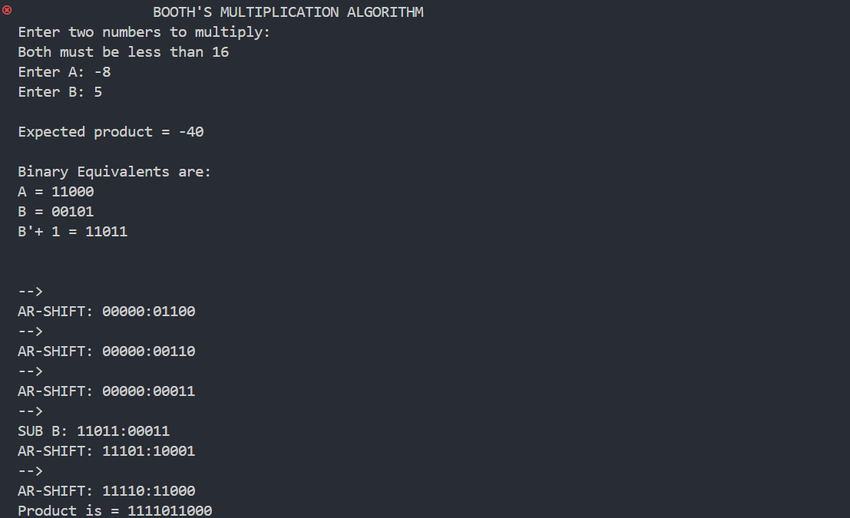

*Fig: Output of Code*